College Algebra Formulas Tests – Use This to Study

Positive | Zero | Negative
$$\left|3x+5\right|=4$$  becomes  $3x+5=4$ or $3x+5=-4$  (drop) (drop/sign flip) | $$\left|3x+5\right|=0$$  becomes  $$3x+5=0$$ | $$\left|3x+5\right|=-4$$  has  $$\boxed{\boxed{No Solution}}$$

For inequalities involving absolute value:
…positive, rewrite as a compound or combined inequality without absolute value bars (see examples below)
>  or  $$≥$$ | $$\left|3x+5\right|>4$$  becomes  $3x+5>4$ or $3x+5<-4$  (drop) (drop/double sign flip) | $$\left|3x+5\right|≥7$$  becomes  $3x+5≥7$ or $3x+5≤-7$  (drop) (drop/double sign flip)
<  or  $$≤$$ | $$\left|3x+5\right|<9$$  becomes the combined inequality  $$-9<3x+5<9$$ | $$\left|3x+5\right|≤2$$  becomes the combined inequality  $$-2≤3x+5≤2$$
…zero, rewrite as an equality or inequality, or state the solution as “All Real Numbers” or “No Solution” (see examples below)
>  or  $$≥$$ | $$\left|3x+5\right|>0$$  becomes the inequality  $$3x+5≠0$$ | $$\left|3x+5\right|≥0$$  has the solution  $$\boxed{\boxed{All Real Numbers}}$$
<  or  $$≤$$ | $$\left|3x+5\right|<0$$  has  $$\boxed{\boxed{No Solution}}$$ | $$\left|3x+5\right|≤0$$  becomes the equality  $$3x+5=0$$
…negative, state the solution as “All Real Numbers” or “No Solution” (see examples below)
>  or  $$≥$$ | $$\left|3x+5\right|>-4$$  has the solution  $$\boxed{\boxed{All Real Numbers}}$$ | $$\left|3x+5\right|≥-7$$  has the solution  $$\boxed{\boxed{All Real Numbers}}$$
<  or  $$≤$$ | $$\left|3x+5\right|<-9$$  has  $$\boxed{\boxed{No Solution}}$$ | $$\left|3x+5\right|≤-2$$  has  $$\boxed{\boxed{No Solution}}$$

Some equation forms of a line:
Slope-Intercept Form Point-Slope Form Standard/General Form
$y=mx+b$ $y-y_{1}=m(x-x_{1})$ $Ax+By=C$

Some equation forms of a circle:
Standard Form General Form
${(x-h)}^{2}+{(y-k)}^{2}=r^{2}$ $x^{2}+y^{2}+ax+by+c=0$
The average rate of change of a function from $a$ to $b$ is $\frac{f\left(b\right)-f(a)}{b-a}$

Given a line passing through points $(x_{1}, y_{1})$ and $(x_{2}, y_{2})$, the slope $m$ of the line is $m=\frac{rise}{run}=\frac{y_{2}-y_{1}}{x_{2}-x_{1}}$ as long as $x_{2}≠x_{1}$

Some equation forms of a parabola:
Vertex Form Standard Form
$y=a{\left(x-h\right)}^{2}+k$ $y=ax^{2}+bx+c$, with vertex $\left(-\frac{b}{2a}, c-\frac{b^{2}}{4a}\right)$

The Law of Exponents:
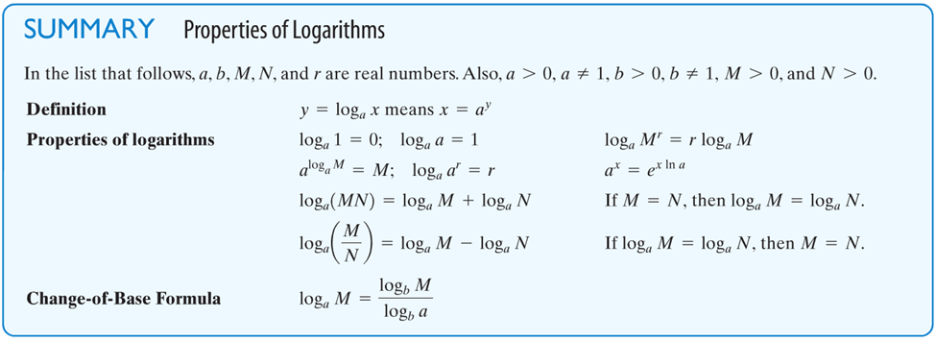
Given $a>0$ with $a≠1$: If $a^{u}=a^{v}$, then $u=v$.

The compound interest formula states that $F=P{\left(1+\frac{r}{n}\right)}^{nt}$

The continuously compounded interest formula states that $F=Pe^{rt}$
The exponential law states that an amount $A$ varies with time $t$ according to the function $A\left(t\right)=A_{0}e^{kt}$ As long as the start time is 0, the value of $k$ can be determined using the adder $a$ and either the multiplier $m$ or the divider $d$:
$\boxed{k=\frac{\ln{m}}{a}}$ or $\boxed{k=\frac{\ln{(1/d)}}{a}}$

